def divided_difference(x, y): n = len(y)

coef = np.zeros((n, n)) coef[:, 0] = y

for j in range(1, n):

for i in range(n - j):

coef[i][j] = (coef[i + 1][j - 1] - coef[i][j - 1]) / (x[i + j]

- x[i])

return coef[0]

def newton_interpolation(x, y, value): coef =

1

for i in range(1, n):

product_term *= (value - x[i - 1]) result += coef[i] * product_term

return result

x_data = [300, 310, 320, 330, 340] # x values

y_data = [45, 50, 65, 70, 75] # corresponding y values

x_value = 301

y_at_301 = newton_interpolation(x_data, y_data, x_value)

print(f"The value of y at x = {x_value} is approximately: {y_at_301:.2f}")

# b. Find the value of y at user input

user_input = float(input("Enter a value for x to find y: ")) y_at_user_input = newton_interpolation(x_data, y_data, user_input) print(f"The value of y at x = {user_input} is approximately:

{y_at_user_input:.2f}")

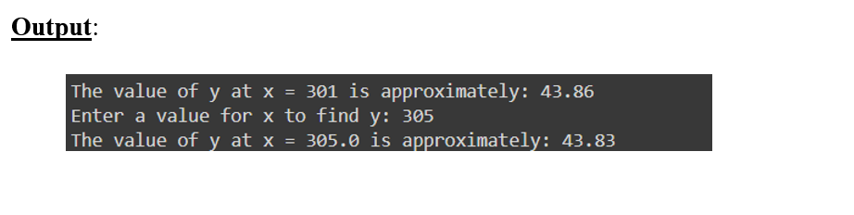

path = kagglehub.dataset_download("ravitejakotharu/salary-datacsv") print("Path to dataset files:", path)

data = pd.read_csv(path + '/salary_data.csv')' x = data['YearsExperience'].values

y = data['Salary'].values n = len(x)

difference_table = np.zeros((n, n)) difference_table[:, 0] = y

for j in range(1, n):

for i in range(n - j):

difference_table[i][j] = difference_table[i + 1][j - 1] - difference_table[i][j - 1]

return difference_table

def newton_interpolation(x, y, xp): n = len(x)

diff_table = newton_difference_table(x, y) h = x[1] - x[0]

result = diff_table[0, 0] u = (xp - x[0]) / h

for i in range(1, n): u_term

j)

result += (u_term * diff_table[0, i]) / np.math.factorial(i) return result

years_of_experience = float(input("Enter the years of experience: ")) predicted_salary = newton_interpolation(x, y, years_of_experience) print(f"Predicted Salary for {years_of_experience} years of experience:

{predicted_salary}")

